Databases 2 Assignment

# Ryan McLoughlin, C21431604

# ERD and Logical

# Logical model

# A logical model for an sql database

# ERD

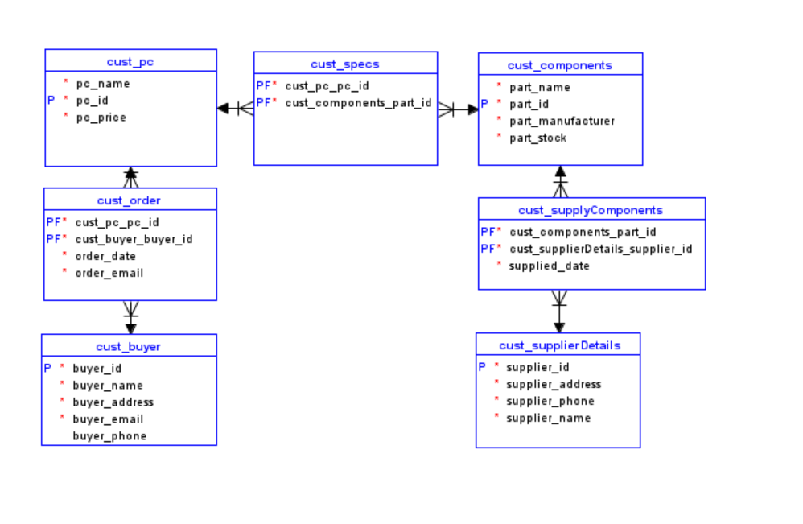

# Reasoning for model structure

The cust_buyer table is a table with the purpose of storing data about customers. This is needed as otherwise we would be unable to know who ordered what PC.

The cust_order table exists to store a customer’s order, and when they ordered it, and who ordered it.

Cust_pc stored the name of a pc model, its ID, and its price.

Cust_specs store what specs a certain pc model has.

Cust components tracks the stock of what parts we have available, who made the parts, and what parts they are, aswell as their ID.

Cust supplycomponents is the table within which deliveries of components are tracked, and what components were in that delivery.

Finally, supplierDetails keeps track of what suppliers we have.

# Role

I took the role of an inhouse technician, who builds PCs.

This role would require me the ability to edit the contents of tables and have read access to the tables of cust_order, cust_pc, cust_specs and cust_components. This is as I would need to see what PC was ordered, how much it is and what it’s ID is, what specs are in this PC, and I would need access to cust_components to be able to edit the amount of stock I used in building a PC. I would also need write access to cust_PC and Cust_specs to add new PC models in the future if it were needed.